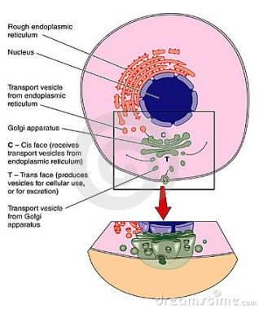
Megan Meyers
Organelles
Golgi Apparatus- It is found in both the plant and animal cells. It mainly directs the carbohydrates and proteins to the right place. It carries out the processing of proteins from the E.R and transports it to different parts of the cell. The Golgi processes proteins then sorts them and finally delivers them.

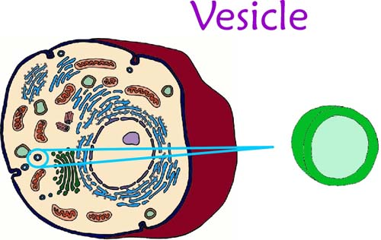
Vesicles- They store and transport different materials to and from different cells and form a part of a cell to another. Basically it keeps substances in the cell and transports them.

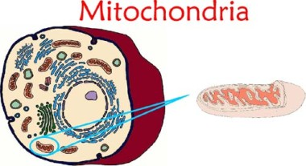
Mitochondria- It’s main function is to make energy and supply it for the cell. The broken down food molecules are transported to the mitochondria which processes it further. The energy produced by the mitochondria is called ATP.

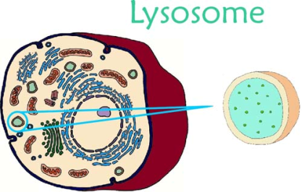
Lysosomes- Lysosomes are found only in animal cells. They are known as the disposal system of the cells. They digest macromolecules that are considered a threat. It doesn’t only digest those materials; it also digests worn out parts.

