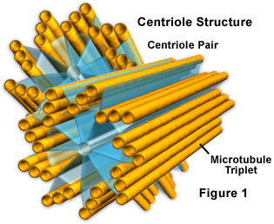
Centrioles
A centriole is a cylinder- shaped structure, found in most animal cells. The centriole is made of small microtubules that are arranged in a specific way and help with cell division.

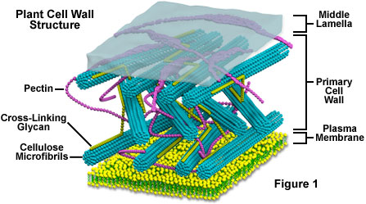
Cell Wall
Cell walls are made of a sugar called cellulose. The cell wall is the rigid, outermost layer of a plant cell. It gives protection, support, and shape to the cell.

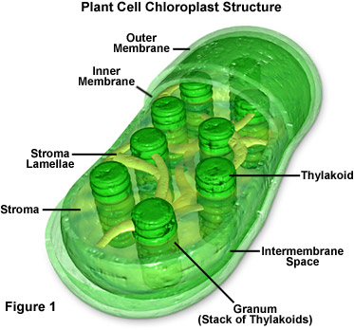
Chloroplasts
Chloroplast captures light energy, stores it and uses it in the process called photosynthesis. Chloroplasts are green because they contain chlorophyll pigment.

