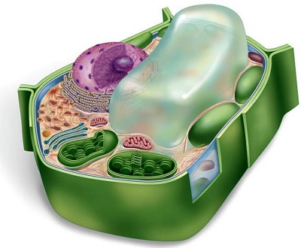
Vacuole
Vacuole
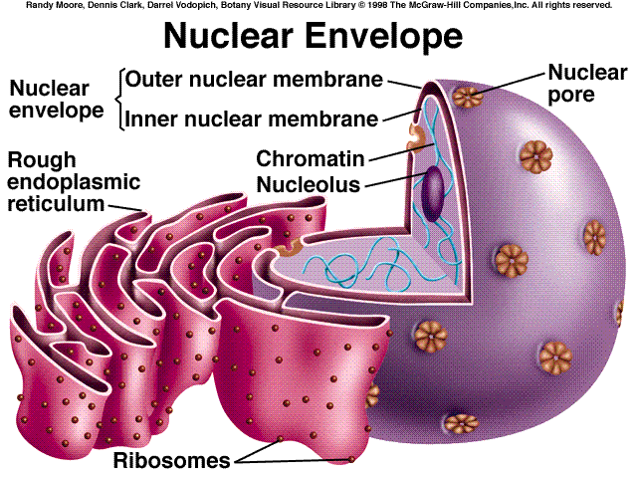
A vacuole is a fluid- filled sac that stores materials the cell might need. These materials could be water, food, inorganic ions, and enzymes. In animal cells the vacuoles is small and in plant cells it is big. In plant cells the vacuole helps increase the size in plant growth. Also, it helps keep the plants structure and sturdiness because if it wasn’t filled with sufficient water the plant would wilt and fall over.

Nuclear Envelope
The nuclear envelope is made up of a lipid bilayer with holes, called nuclear pores that surround the nucleus. These pores can regulate what travels between the nucleus and the cytoplasm. The nuclear envelope protects the nucleus because it is like the brain of the cell. The outer layer of the lipid bilayer is continues with the endoplasmic reticulum.
Close Up of a Ribosome
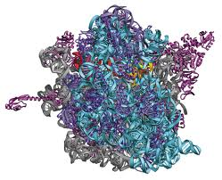
Ribosome
Ribosomes are organelles that consist of RNA and proteins. They are responsible for assembling the proteins of the cell. Depending on the protein production level of a particular cell, ribosomes may number in the millions. You can find ribosomes in cytosol or the rough endoplasmic reticulum.
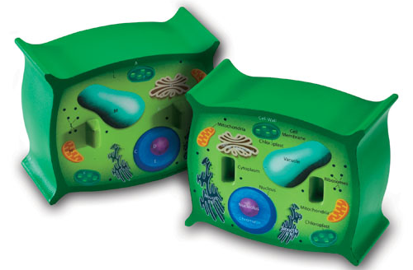
Cell Membrane
The cell membrane protects the interior of the nucleus from the outside environment. It is made of a lipid bilayer with proteins in it. The cell membrane is selectively permeable to ions and organic molecules and controls the substances in and out of cells. The cell membrane is found both on the animal cell and the plant cell.
Cell Membrane

